**PREPROCESSING**

**Question 1:**

**(a) How is the data structured? Draw a directory tree to represent this in a sensible way.**

The data is in two parts: the collection of daily climate summaries, which are grouped by year into separate files and stored in a gzip compressed csv format, and the associated metadata providing additional data specific to each of the stations, states, countries, and inventory.

The data is structured according to the directory tree below



where stations, states, countries, and inventory are files and daily is a directory containing one file for each year.

**(b) How many years are contained in daily, and how does the size of the data change?**

Totally there are 255 files in daily so there are 255 years in total. The size of the data change from KB to MB.

**(c) What is the total size of all of the data? How much of that is daily?**

The total size of the data is 13.4 GB, most of which is daily. All of the metadata combined only contributes 36.3 MB to the total. As the daily data is compressed, and the actual size of the uncompressed data will be significantly higher. The gzip compression ratio for csv files is usually around 10:1 so this could be between 100 GB and 1 TB.



The schema of daily is described in the assignment already, and the head of each file is consistent with the schema as expected. To look at the head of daily, we had to pipe the file through gunzip and pipe the decompressed csv data to head.

**Question 2:**

1. **Define schemas for each of daily, stations, states, countries, and inventory.**

The schemas for daily, stations, states, countries and inventory are defined based on the descriptions in the assignment and the GHCN Daily readme file while using the data types defined in pyspark manual.

**(b) Load 1000 rows of hdfs:///data/ghcnd/daily/2017.csv.gz into Spark using the limit command immediately after the read command.**

The 2017.csv.gz daily file is loades only for the first **1000** records using the spark.read.format command to read the csv file by making using of the daily schema defined in a.

**Was the description of the data accurate? Was there anything unexpected?**

Based on loading the first 1000 rows of daily in pyspark the description of the data above and in the assignment is accurate. However, the data for the DATE column wasn’t given in a standard DATA format. Hence the column is converted into string at first then converted to a DATE column manually.

1. **Load each of stations, states, countries, and inventory into Spark as well.**

The schema of the data for countries, states, stations and inventory could not be loaded directly as the data is not present with a separator but in fixed width format. So the columns must be extracted by selecting the substring which is relevant. This is achieved by using the substring command while reading the file then apply the schema on the extracted data.

**How many rows are in each metadata table? How many stations do not have a WMO ID?**

The countries data has 218 rows which represents all the countries around the world. The states data has **74** rows which represents only the US and Canadian states/provinces. The inventory data has **595699** rows in total which is a listing of periods of record for each station and element. The stations data has **103656** rows representing all the stations around the world and their geographical location and other details.

The number of stations not having WMO ID is **95595**.

**Question 3:**

**(a) Extract the two-character country code from each station code in stations and store the**

**output as a new column using the withColumn command.**

The country code is a two character word which needs to extracted from the first 2 characters of the metadata. So a substring command is used to extract these 2 characters and save it as a new column.

**(b) LEFT JOIN stations with countries using your output from part (a).**

The stations dataset and countries dataset have a common column for country code. Hence there can be joined. Here we are doing in a left join which considers all the rows from the stations dataset and only the matching ones from the countries dataset.

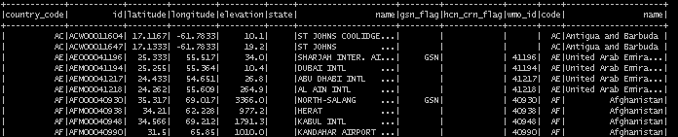

1. **LEFT JOIN stations and states, allowing for the fact that state codes are only provided for stations in the US.**

The stations dataset is joined with the states dataset based on the state code column from both the datasets. It is left joined on stations data.



**(d) Based on inventory, what was the first and last year that each station was active and collected any element at all?**



The first and the last year of the inventory dataset is determined by initially grouping the data by id and aggregating the first year column with ‘min’ function and last year column with ‘max’ function.

**How many different elements has each station collected overall?**



To determine the number of unique elements in the inventory dataset. The data is grouped by both id and element and aggregated by element count to determine if there are any multiple count for the same elements for a station. But all the elements were unique for a station. Hence the same data is again grouped by id and the count of elements were taken for each station.

**Further, count separately the number of core elements and the number of ”other” elements that each station has collected overall.**

**How many stations collect all five core elements? How many only collection precipitation?**

Two new columns core_flag and prcp_flag are created. The inventory data is filtered for core elements and the count is taken as value for core_flag, similarly the precipitation count is taken for prcp flag. Then the inventory dataset is grouped by id and aggregated for calculate the count for total elements, core elements and precipitation element. A new column for other elements is created and the values are populated by subtracting total elements count and core elements count.

Totally 20224 stations collect only the core elements. Also 101614 stations contains only precipitation element.

This is calculated by taking the sum of count of the core_elements and prcp_elements column.

We can also create a collect_set for every station id with the collection of every element corresponding to that station.



**(e) LEFT JOIN stations and your output from part (d).**



The output from d) is left joined with stations based on the stationed.

**(f) LEFT JOIN your 1000 rows subset of daily and your output from part (e).**

Only 1000 rows is extracted from daily and left joined with the output from e).



If the whole daily dataset is set to join with the stations dataset. It would be a very expensive process as the rows count for daily is 2e^9 and stations row count is 1e^5.

**Are there any stations in your subset of daily that are not in stations at all?**

The join count is 1000 which means all the stations in daily are present in stations dataset. So there are 0 stations in daily subset that are not present in stations dataset

**ANALYSIS**

**Question 1:**

**(a) How many stations are there in total? How many stations have been active in 2017?**

There are totally **103656** unique stations in total. And around **306** stations were active in 2017.

**How many stations are in each of the GCOS Surface Network (GSN), the US Historical Climatology Network (HCN), and the US Climate Reference Network (CRN)? Are there any stations that are in more than one of these networks?**

The number of station is GCOS Surface Network is **991.**

The number of stations in US Historical Climatology Network is **1218.**

The number of stations in US Climate Reference Network is **230.**

None of the stations exist in all 3 networks.

1. **Count the total number of stations in each country, and store the output in countries using the withColumnRenamed command.**

**Do the same for states and save a copy of each table to your output directory.**

 

The stations data is grouped by country code and aggregated based on count of country_code. Similar method is followed to find the states count but the state column is used instead.

**(c) How many stations are there in the Southern Hemisphere only?**

The number of stations in the southern hemisphere is determined by filtering the station dataset by any latitude below 0. There are totally **25337.**

**Some of the countries in the database are territories of the United States as indicated by the name of the country. How many stations are there in total in the territories of the United States around the world?**



The number of stations is in the US territories can be obtained by grouping the stations data with state and aggregate by count. The states data is available only for US territories.

**Question 2**

**(a) Write a Spark function that computes the geographical distance between two stations using their latitude and longitude as arguments.**

As first thing filter the stations dataset only for the stations in NZ. Then do a cross join to create a pair of stations for every possible combination pair of stations in NZ and filter out the ones with same stations in a pair.



The latitude and longtitude of the station pairs are applied to the get_distance() function which returns the geographical distance between the two stations.

We could see the closest stations are the **Wellington AERO AWS** and **PARAPARAUMU AWS** with a distance of **51.27 units.** The output is also saved to the output directory.



**Question 3**

**a) determine the default blocksize of HDFS**

To determine the block size the command **hdfs getconf -confKey dfs.blocksize** is used.

The default block size is 134217728 Bytes (128MB).

**How many blocks are required for the daily climate summaries for the year 2017 and 2010?**

Size of daily summary file for the year 2017 - **125.5 M** 477.8 M /data/ghcnd/daily/2017.csv.gz

Therefore just 1 block is required to store the daily summaries of 2017

Size of daily summary file for the year 2010 - **205.6 M** 790.3 M /data/ghcnd/daily/2010.csv.gz

Therefore 2 blocks will be required to store the daily summaries of year 2010

**Based on these results, is it possible for Spark to load and apply transformations in parallel for the year 2017? What about the year 2010?**

Since there is only one block for 2017 file spark cannot load and apply transformation in parallel. Whereas for 2010 file there are 2 blocks so load and transformation can be done in parallel.

**(b) Load and count the number of rows in daily for each of the years 2010 and 2017.**

Using the count command the number of rows in 2010 daily is determined to be **36946080**. Similarly, the count command the number of rows in 2010 daily is determined to be **21904999.**

Both these load operations require 2 stages with 1 task each. So 2 tasks for a single load and count operation.

**c) Load and count the number of rows in daily from 2010 to 2015.**

The daily file is loaded from 2010-2015 and the count of the number of rows is found to be 207716098.

The same files are loaded by using a regular expression to load the file and the file count remains the same.

**Find out how Spark partitions input files that are compressed**

Usually GZ files has lesser memory and they load quite fast. But they also have a drawback as the file cannot be split and partitioned while processing, hence parallelism cannot be attained. Meanwhile BZ files have low level of partitioning capabilities but does perform as good as uncompressed files.

**(d) Based on parts (b) and (c), what level of parallelism can you achieve when loading and applying transformations to daily? Can you think of any way you could increase this level of parallelism either in Spark or by additional preprocessing?**

A good level of parallelism can be achieved by repartitioning the data into multiple partitions in multiple cores. This way the work load is evenly split and the output is obtained is a an efficiently quick time. The number of executors can also be increased for better parallelism.

**Other methods:**

* Native Spark – The native spark libraries are designed in such a way that dataframes are naturally parallelized.
* Thread pools – Python threads are executed in parallel with the use of this library. It also supports Data frames.
* Pandas UDFs – The spark data frame is converted to pandas dataframe and it is divided into many small data frames to work in parallel. Then after the transformation is complete it is converted back to spark dataframe.

**Question 4**

**a) For this question of the assignment, all of daily has been loaded.**

The total number of rows in daily is **2624027105**.

**b) By using the filter command, the subset of observations containing the five core elements ('PRCP', 'SNOW', 'SNWD', 'TMAX', 'TMIN'") described in inventory has been extracted.**

|  |  |
| --- | --- |
| Element | Count |
| PRCP | 918490401 |
| TMAX | 362528096 |
| TMIN | 360656728 |
| SNOW | 322003304 |
| SNWD | 261455306 |

|  |  |
| --- | --- |
| Element | Count |
| PRCP | 101614 |
| TMAX | 34109 |
| TMIN | 34012 |
| SNOW | 61756 |
| SNWD | 53307 |

From the table, Precipitation (PRCP) has the most number of observations.

From the inventory table, we can see Precipitation (PRCP) has the most number of observations. However the SNOW & SNWD elements are more than TMAX & TMIN elements in inventory which is not the case in daily table. Hence they are inconsistent.

**c) Determine how many observations of TMIN do not have a corresponding observation of TMAX.**

In order to filter the observation which has the TMIN element but the TMAX element. The daily data is grouped based on id and a collect set is formed by the list of elements present in one particular id. Then this collect set if filtered with sets containing TMIN but not TMAX using the contains command. Totally there are 141 observations.

**How many different stations contributed to these observations? Do any belong to the GSN, HCN, or CRN?**

There are totally **141** unique stations in the observations.

There are **2** observations with **GSN** flag and **zero** observations with **HCN/CRN flag.**

There are **14** observations with a valid **wmo_id**.

**(d) Filter daily to obtain all observations of TMIN and TMAX for all stations in New Zealand, and save the result to your output directory.**

The filter command is used to filter the daily observation based on the country “NZ” and also based on the elements “TMAX” and “TMIN”. There are totally **447017** observations. The filtered daily observations are saved as a csv file in output directory.

There are totally 156 years totally covered.

The file is saved to local by using the command hdfs dfd -copyToLocal command to copy from hdfs to local. The row count of the file is determined by using cat command on the file and doing a pipeline with command wc-l to find the total observation count.





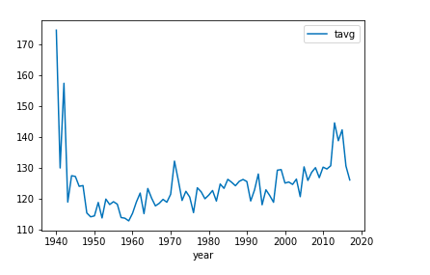



e) The daily data is filtered only for “PRCP” observation and grouped by each year and country. And the average rainfall is computed and the result is saved to the output directory.

The country with highest average rainfall per year is **Equatorial Guinea**.





**Challenges**

**Q1 Analyse the Daily File**

The daily data is converted into two different data frames to analyze the data both temporally and globally.

In one data frame the daily data is grouped by year and element and aggregated based on sum of value. In another data frame the daily data is grouped by year and element and aggregated based on sum of value.



WSF1 = Fastest 1-minute wind speed (tenths of meters per second)

WSF2 = Fastest 2-minute wind speed (tenths of meters per second)

WSF5 = Fastest 5-second wind speed (tenths of meters per second)

WSFG = Peak gust wind speed (tenths of meters per second)

WSFI = Highest instantaneous wind speed (tenths of meters per second)

WSFM = Fastest mile wind speed (tenths of meters per second)

A list of wind elements is represented in a time series.



ACMH = Average cloudiness midnight to midnight from

manual observations (percent)

ACSH = Average cloudiness sunrise to sunset from manual

observations (percent)

We could see that there was a significant difference in the value of the cloudiness between day and night during the starting years but later on both the values are almost equal.

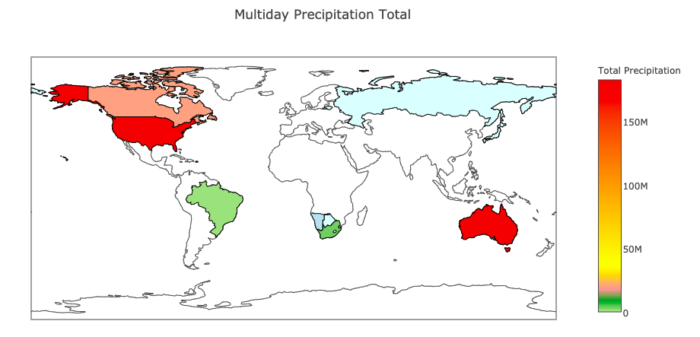

MDPR = Multiday precipitation total (tenths of mm; use with DAPR and DWPR, if available)

**Question 2:**

**Investigate the quality flag in daily.**

**How many rows in daily failed each of the quality assurance checks?**

Quality flag represents the quality check for the recording of each day. Below are the 10 possible value of Quality flag. If the value is null then there was no quality failures.

|  |  |
| --- | --- |
| Value | Inference |
| Blank/null | did not fail any quality assurance check |
| D | failed duplicate check |
| G | failed gap check |
| I | failed internal consistency check |
| K | failed streak/frequent-value check |
| L | failed check on length of multiday period |
| M | failed mega-consistency check |
| N | failed naught check |
| O | failed climatological outlier check |
| R | failed lagged range check |
| S | failed spatial consistency check |
| T | failed temporal consistency check |
| W | temperature too warm for snow |
| X | failed bounds check |
| Z | flagged as a result of an official Datzilla |
| investigation |

There are **2624027105**. records or rows in Daily. Out of the **2624027105** records, **46713** records have failed the quality assurance checks. This implies just **0.21%** of the data has failed for quality checks. Hence the majority of the data is accurate and of good quality.

This model is quite good for training a statistical model due to its highly accurate values. And the output predictions will be close to the real values.

The number of quality failures is group based on every US state and plotted in a map.

We can see that there are more quality failures in the states of the west. Namely the states like **California, Texas and Orleans**.

